SHIVALIK PUBLIC SCHOOL, MOHALI
PLANNER FOR THE MONTH OF OCTOBER AND NOVEMBER 2019
CLASS– 2

Dear Parent

Greetings from Shivalik Public School !
The tiny tots have surpassed the first milestone of this session with the recent exams and the school is again abuzz with their activity after the holidays. We will do our best in keeping this energy going in them. Here is to hoping that with your support, they will continue with the same enthusiasm in the upcoming festival season with which they started the school year.
ACTIVITY PLANNER
OCTOBER
Special Days Activities
- National Child Health Day (October 1,2019 )Tuesday:- Yoga exercises and aerobics for beginners will be taught.
- ( Video on the life and teachings of Mahatma Gandhi, will be shown. “Gandhi ji”- My inspiration activity will be organized.)
- Dusshera activity(October 4, 2019) :- Craft activity will be conducted.
- October 5,2019: Intersection English calligraphy competition
- World Food Day (October 16, 2019) Wednesday: - Fruit salad making competition will be conducted.
- October 19,2019 Saturday- Annual Function
- October 23,2019, Wednesday- Clean your classroom activity.
- October 25,2019 Friday- Diwali celebrations (Assembly) will be held .
NOVEMBER
- November 6, 2019 – Canteen day
- November 7,2019 – Show and tell Activity ( Means of transport )
- November 11, 2019 -- Special assembly on Guru Nanak Dev Ji birthday.
- November 13, 2019 - Intersection Hindi calligraphy competition
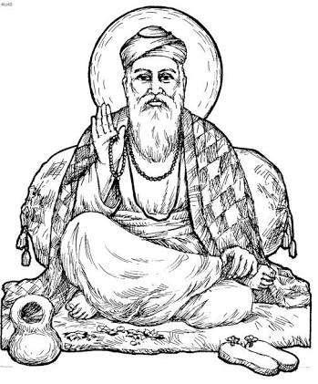
- November14,2019 Thursday- Children’s day celebrations.
- November – Picnic

Dussehra Break :- Oct 7,2019 and October 8,2019.

Diwali Break :- October 26,2019 to October 29,2019.

Syllabus of unit test -3
ENGLISH : Unit -6 and Unit – 7
Reading comprehension: lesson – 1(In the park) and 2 ( Sky is falling)
Vocabulary : Play with words ( Page nos – 9 , 18 and 19 )
Spell it right ( Page nos- 10 and 19)
Grammar : Know grammar (page nos-10, 11 and 20 ) , grammar worksheet 1 (page 59 to 61 ) and grammar worksheet 2 (page nos – 61 to 63 )
Creative writing : Think and Write ( page – 12 and 21 )
Make sentences – picnic , playground , basket, hungry , dustbin , king, flower, wish, jungle , dance.
Recitation – The fly (poem ) ; Dictation words

MATHEMATICS : Unit – 6 and Unit – 7
Chapter -1 : Multiplication
Chapter -2: Division
Chapter – 3: Fractions
Tables : 2 to 10 and dodging tables

HINDI : Unit – 6 and Unit – 7
Reading comprehension : Lesson – 11 (आलसी दिनेश) , 12(अच्छे बच्चे) , 13 (आई दीवाली) and 14(पूजा का नारियल)
Grammar विपरीत शब्द- धूप, गाँव,अच्छा,गन्दा, चढ़ना, ईधर
विपरीत शब्द- धूप, गाँव,अच्छा,गन्दा, चढ़ना, ईधर
वाक्य बनाओ- तरह-तरह के, रखवाली, प्रभु, शीश, रोज़,दीवाली, मिठाई, दुकान, घर, नारियल
Recitation : Lesson 12 and 13 and Dictation words

PUNJABI : Unit - 6 and Unit -7

ART AND CRAFT : Unit -6 and Unit – 7
Art : Draw and colour Dussehra scene , a santa and Christmas tree ; colouring pages – 18,19,20,21,22,23,24, 25 and 27.
Craft : Paper crown , Paper whale and page no. – 26.

