SHIVALIK PUBLIC SCHOOL, MOHALI
PLANNER FOR THE MONTH OF JULY- 2019
CLASS-NURSERY
Dear Parents,
Welcome back after a summer vacations. We hope the children had an enjoyable and relaxing summer break and are ready for the new term.
A few friendly reminders-
- In our endeavour to develop self reliance skills in our children, please encourage your child to walk into school on his/her own from the school gate.
- The school starts at 8:30 am, please ensure that your child reaches the school in time.
ENGLISH (World of Letters)
- Meet the Letter Ee (Page no-28-29)
- Meet the Letter Ff (Page no-30-31)
- I Know A TO F (Page no-32)
- Picture Talk (Page no-33)
- Meet The Letter Gg (Page no-34-35)
RHYMES
- 1,2,3,4,5 ONCE I CAUGHT A FISH ALIVE
One, two, three, four, five,
Once I caught a fish alive,
Six, seven, eight, nine, ten,
Then I let it go again.
Why did you let it go?
Because it bit my finger so.
Which finger did it bite?
This little finger on my right

- बारिश आई छम छम छम
बारिश आई छम छम छम
लेकर छाता निकले पड़े हम
पैर फिसला गिर गए हम
उपर छाता नीचे हम ।
MATHS (World of Numbers)
- Shapes Around Us: Triangle (Page no-21)
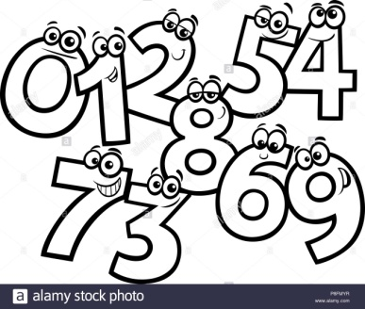
- Fun with Shapes (Page no-22)
- I can spot the Differences! (Page no-23)
- Patterns around Us (Page no-24-27)
- I green Parrot (Page no-28-30)
DRAWING BOOK ( GRAFALCO)
- Scribble with different colours (Page no 2-7)
- CRAFT:-Blue day craft
- Paper folding (Triangle)
- Clay moulding
THEME
Good Manners, Rainy Season
Self Sufficiency skills
- How to wash your hands.
- Setting a Table.
- Lifting a Chair.
GENERAL KNOWLEDGE
Q1.What is your Name?
Q2.What is your School name?
Q3.What is your Teacher name?
ACTIVITIES
Paper folding (Triangle) (05.07.2019)
Fun with Shapes (09.07.2019)
Mango Party (10.07.2019)
Pouring Activity (19.07.2019)
Show and tell (23.07.2019)
(Topic: Fruits- Child will speak 3-4 lines on the topic)
Lemonade making activity (24.07.2019)
Washing Hands (25.07.2019)
Blue Day (31.07. 2019)
(Children will come in blue dress)

ENGLISH ACTIVITIES
- Student will make a train and walk on railway track drawn on floor, it will become a engine- RECOGNITION OF LETTER E.
- Recognition of F-Student will count five fingers and decorate a fish. Craft of F- fish will be given.
- Recognition of G-School gate will be shown and tell them how they must never go out on their own.

