SHIVALIK PUBLIC SCHOOL, MOHALI
SUMMER BREAK ASSIGNMENT XI, ENGLISH – Submit in separate folder- properly written answers.
HORNBILL
1. THE PORTRAIT OF A LADY:
- Why would Khushwant Singh listen to the prayers recited by his grandmother?
- Which act of grandmother shows she is kind to animals and birds?
- How did grandmother react when Khushwant Singh was going abroad?
- Why did the sparrows not eat the bread crumbs given by Khushwant Singh’s mother?
- Why is grandmother described as ‘an expanse of pure white serenity?’
- What do you understand about the grandmother in the way she accepted her seclusion.
- ‘nature mourns the death of pure’ Describe in the light of grandmother.
- How did grandmother accept her death?
- Grandmother is a mentally strong lady. Explain.

Long answer type questions:
- Describe why grandmother preferred village environment to the city environment.
- Compare and contrast village education with city education.
- ‘Respecting old age is respecting traditions’. Elaborate.

“We’re Not Afraid to Die ….. if We Can All Be Together”
Short answer questions
- What was special about December 25?
- Describe the journey of the narrator with his family on Jan 2.
- Describe the gigantic wave that dropped the narrator overboard.
- What injuries were sustained by Sue?
- How does Jon try to comfort his father?
- What surprise did the narrator receive when he woke up at 6 p.m.?
- What were the indications of the impending disaster?
- What happened to the boat after the narrator was thrown overboard?
- Describe the grit exhibited by children during the journey.
- Describe the card made by Sue.
- Why does the narrator call Ile Amsterdam –the most beautiful island in the world?
- Why does the narrator say that their respite was short lived?
Long answer questions
- Describe the courage shown by children when they faced danger during their voyage.
- What was the scenario experienced by the voyagers on Jan 3?
- Justify the title of the story.
- “Staying together in times of direst of situation helps”. Describe in light of the story.
A Photograph
Short questions
- What does the poet mean by “terribly transient feet”.
- Is the poet able to cope up with the loss of her mother?
- Has time healed the poet’s wounded feelings?
- What makes the mother laugh when she sees the photograph?
- Explain‐‘ Both wry‐‐‐‐‐‐‐‐‐‐ ease of loss’.
SNAP SHOTS
Summer of the Beautiful White Horse
Short Answer Type Questions
- What did Aram think of the world when he was nine?
- What did everybody think about Mourad?
- How does the narrator feel when he realized that his cousin had stolen the horse?
- The narrator was proud of his tribe’s honesty then why did he agree to enjoy riding a stolen horse?
- What did uncle Khosrove say when his son told him that their house was on fire?
- Long Ans Type Questions
- You lost your cycle a day before. Write a notice for the school notice Board about it and announce a suitable reward for it.
- Draft a Poster with the message—SAVE ANIMALS.
The Address
Short Answer Type Questions
1. What was the address referred in the story? How did the narrator get it?
2. Who was Mrs. Dorling? Why did she deny to recognize the narrator?
3. Why did the narrator want her mother’s belongings?
4. Briefly enlist the articles the narrator recognized as her own in Mrs. Dorling’s house?
5. What was the attitude of Mrs. Dorling’s daughter towards the belongings of the narrator’s mother?
6. How did the narrator recognize that the cutlery was her own?
7. “Bread was getting to be a lighter colour,…”Explain it.
WRITING SKILLS‐CLASS
NOTICES
1. You lost your pen drive in the school. Draft a notice to be put up on the school notice board. You are Pallavi/Piyush of Bal Nivas Vidyalaya.
2. You are the literary captain of Vivekanda school. Your school is celebrating grandparents’ day. Draft a notice to be put up on the notice board asking the students to invite their grandparents. Invent all the details.
POSTER WRITING
- Design a poster to be put up in the school library on the value of books.
- Design a poster for a school fete.
- Design a poster against exploitation of children as labourers in harmful industries like cracker factories.
CLASSIFIED ADVERTISEMENT
- You have lost your brief case while travelling to Chennai by bus. Draft an advertisement to be given in the local daily. Invent all the details.You are Shalini/Sunder.
- You are setting up crèche in your area. You need a trained nurse for the crèche. Draft a suitable advertisement inventing all the details.You are Ashok/ Ashoka of Belgaum.
- Kendriya vidyalaya Mysore needs contractual teachers in English .Draft an advertisement on behalf of the principal in the classified columns of the local newspaper.
REPORT WRITING./FACTUAL DESCRIPTION
- Inter School Regional Level Science exhibition was held in your school. As the science captain of your school you have been asked to write a report for the newspaper.
- You are Preeti the secretary of the literary club of the Vidyalaya. Write a report for the school magazine on the activities of the club during the current year.

SECTION A - BBC – DO FIRST FIVE NOTE MAKING AND COMPREHENSION EXERCISES
ASSIGNMENT – 1
COMPLEX NUMBERS
CLASS - 11
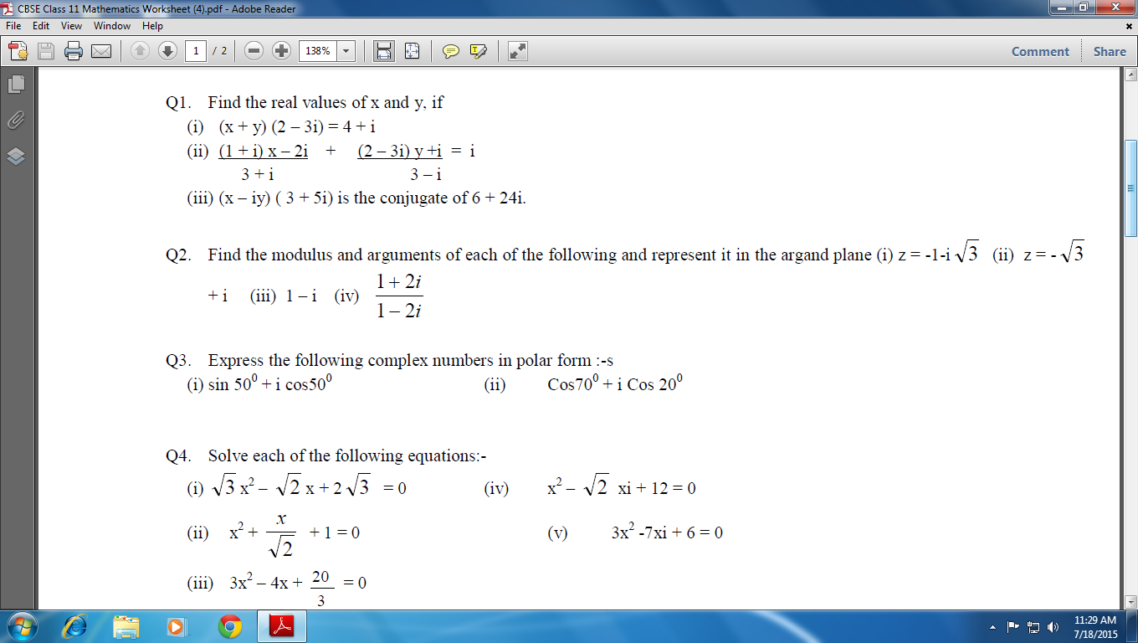

Mathematical induction assignment

CHEMISTRY
- To complete NCERT exercise of already discussed chapters.
- To prepare Chemistry Project Report as already discussed.
BIOLOGY
- Prepare a project file on the topics distributed individually to the students
- Collect medicinal and economically important plants. And prepare a herbarium file.
- Complete the assignment in Biology Notebook
- Complete practical experiments (No. 1 to 5) in practical file.

HEALTH AND PHYSICAL EDUCTAION
- STRAND-1 (GAMES/SPORTS) ANY GAME
- STRAND-2(HEALTH & FITNESS) YOGA/MASS P.T/ AEROBICS

