SHIVALIK PUBLIC SCHOOL, MOHALI
PLANNER FOR THE MONTH OF NOVEMBER-2019
CLASS-LKG
Dear Parents,
Greetings as we begin November!
No sunshine,lots of rain.
No warm days.
No bugs or bees,
No leaves on trees.
You must remember,
This is November!
ENGLISH :-
- Letters-g,h,i,j and k.
- Reading-Page 12.
Rhymes
- The vegetable train
- Engine
ACTIVITIES
- Visit to gurudwara (November 11,2019)
- Community lunch (November 14,2019)Children will come in casual dress.
- Show and tell intra section topic –Favourite Toy (November 22,2019)
- Canteen day (November 27,2019)
- Show and tell inter-section topic –Favourite Toy (November 29,2019)
Story
• The Chick and The Duckling
MATHS: -
• Meet more Numbers (21 to 30) – Page . 92
• Far and Near – Page . 24
• Full and Empty – Page . 25
• Same and Different – Page . 26
• 1 to 20 with Thumbprints–Page . 76
• Farm Fun – Page . 77
• I can Paste – Page . 78
E. V. S
• Flowers
• Vehicles

ART
• A Boat
- Colouring in flower5 and vehicles.
CRAFT
- Clay moulding(grapes)
RHYMES
ENGINE
Down by the station
Early in the morning
See the little wagons
All in a row
man in the engine
Pulls the little lever,
Chuck,chuck,puff,puff
Off we go.
CLASS TEACHERS:
STORY-:THE CHICK AND THE DUCKLING
The chick and the duckling were friends. But the chick always copied the duckling. One day the duckling went for a walk. The chick said “Me too” and went along. On the way the duckling drank the water. The chick said “Me too” and drank the water. Then the duckling went for swimming. The chick said “Me too” and jumped into the pool. But it did not know how to swim. The duckling pulled the chick out and saved it.
MORAL: Never copy your friends.

THE VEGETABLE TRAIN
The vegetable train says chook ,chook,chook
Come and have a look ,look,look
Vegetables are so good to eat,
They can make a tasty treat
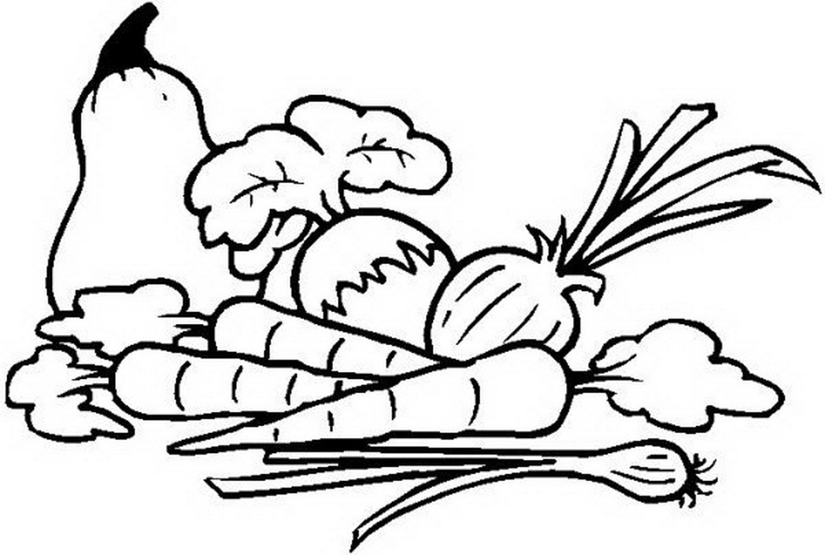
L.K.G-.M L.K.G.- S L.K.G.- A
Ms.Rini Dhodi Ms.Sonika Sharma Ms. Shristi

