SHIVALIK PUBLIC SCHOOL,MOHALI
PLANNER FOR THE MONTH OF DECEMBER- 2019
CLASS–NURSERY

ENGLISH-(WORLD OF LETTERS)
- Meet the letter Xx (page no-72-73)
- Meet the letter Yy (page no-74-75)
- Meet the letter Zz (page no-76-77)
- FLOWERS IN MY GARDEN
Flowers in my garden,
Oh what a fun.
Thank you rain, thank you sun
Yellow and red,pink and blue.
Pretty as me , lovely as you.
I’m just a juicy apple
I’m just a juicy apple
Lying on a tree
If you’re really hungry Come and pick me.
I’m just a rosy apple
Red and juicy too
So come and pick me
I’m good for you.
RHYMES
UP IN THE BLUE SKY
Up in the blue sky
What do you see
Big birds small birds
Looking at me
Flying flyingsha la lala -2
Deep in the ocean
What do you see
Big fish small fish
Looking at me
Swimming swimmingsha la lala -2
Out in the garden
What do you see
Big flower small flower
Looking at me
Blooming bloomingsha la lala -2

MATHS
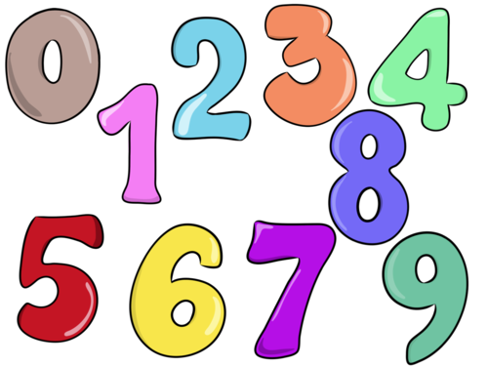
- I can trace! (page no-68)
- I can match! (page no-69)
- My activity page (page no-70-71
- I can draw! (page no-72)
EVS
- Meet the colours(Blue and Red)
- Fruits.
- Patterns
- Festival Christmas (Coloring in Christmas tree)
G.K questions

1. Who is the Prime Minister of India?
2. What are the different modes of transport?
3. When do we celebrate Christmas?

ACTIVITIES
Paper folding (Dog) (05.12.19)
PPt on Healthy food (13.12.19)
Handkerchief Folding (16.12.19)
Nature walk (19.12.19)
Christmas Celebration (23.12.19)
- (Students will come in red dress and gift exchange activity will be done in the class)
- Kindly send gift worth rs 20 till date 20.12.2019

Please Note:-
Saturday December 21,2019Parent Teacher Meeting ,
The parent teacher meeting is an important component of the ongoing home-school communication and family involvement We look forward to meet you.
Winter Break starts from 25.12.2019 to 07.01.2020 .
School will reopen on 08.01.2020.

