SHIVALIK PUBLIC SCHOOL, MOHALI
PLANNER FOR THE MONTH OF FEBRUARY AND MARCH-2020
ENGLISH (World of Letters)
- Trace and match (Pages-86)
- I can trace! (Pages -87-90)
- Trace and match (Pages -91)
- Listen, find and trace (Pages -92-93)
- Listening texts (Pages -96)
RHYMES
- Revision of all rhymes
DISCOVERY
- Songs and Rhymes on Multimedia.
- PPT- Fruits, vegetables, animals , transport.
MATHS (World of Numbers)
- I can trace! (1to 10) (Pages -84-85)
- learning numbers (Pages-86-87)
G.K (Questions / answers)
- What is your name?
- What is the name of your school?
- What is your teacher’s name?
- How many colours are there in the rainbow?
- What is the name of our country?
- Which is the National animal of India?
  - Which is the National Flower of India?
  - Which is the National Bird of India?
  - Which is the National Tree of India?
  - Which is the National Song of India?
  - What is the colour of grass?
  - What is the colour of the sky?
  - What is the colour of an apple?
  - What is the colour of your hair?
  - Name the three colours of traffic light.
ACTIVITIES DATE
- Parent Teacher Meeting 15th February,2020(Saturday)
- Bread, jam activity 19th February,2020 (Wednesday)
- Clay Moulding activity 20th February,2020 (Thursday)
- See the picture and circle the letter 25th February,2020(Tuesday)
- Making of Alphabets with Ice-cream stick 4th March,2020(Tuesday)
- Concept of Shapes 6th March,2020(Friday)
- Recognition of Colours 9th March,2020(Friday)
- Recognition of Numbers and letters 12th March,2020(Thursday)
- Demonstration and Evaluation 14th March,2020 (Saturday)

FLOWERS IN MY GARDEN

Flowers in my garden,
Oh what a fun.
Thank you rain, thank you sun
Yellow and red, pink and blue.
Pretty as me , lovely as you.

UP IN THE BLUE SKY
Up in the blue sky
What do you see
Big birds small birds
Looking at me
Flying flying sha la la la -2
Deep in the ocean
What do you see
Big fish small fish
Looking at me
Swimming swimming sha la la la -2
Out in the garden
What do you see
Big flower small flower
Looking at me
Blooming blooming sha la la la -2

I’m just a juicy apple
I’m just a juicy apple
Lying on a tree
If you’re really hungry Come and pick me.
I’m just a rosy apple
Red and juicy too
So come and pick me
I’m good for you.

गोल -मटोल
मम्मी जी की रोटी गोल ,
पापा देते पैसा गोल ,
दादा जी का चश्मा गोल ,
दादी जी की बिंदिया गोल,
सूरज गोल, चंदा गोल
धरती गोल,
सारी दुनिया गोल –मटोल।

STORY
UNION IS STRENGTH

Once upon a time, there was a farmer. He had three sons .They always quarrelled. One day the farmer brought a bundle of sticks. He ordered his sons to break them but they failed. Then he untied the bundle. He again ordered his sons to break the sticks. Now they broke them easily.
He told them that “Union is Strength”.
MORAL: Union is Strength.
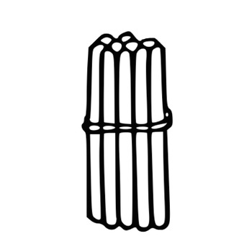

STORY
A MAGIC TREE
A long time ago a little boy was walking through a park. There he saw a magic tree with a sign on it” I AM A MAGIC TREE. Say the magic words and you will see”.
The boy tried abracadabra, tan-ta-ra and many more….but none of them worked.
Exhausted, he threw himself on the floor, saying “Please, dear tree!”and suddenly ,a big door opened in the trunk. Then the boy said “Thank you, dear tree!”With this, the inside of the tree lit up brightly and revealed a pathway leading to a greatbig pile of toys and chocolates.
MORAL: Always be polite.

