SHIVALIK PUBLIC SCHOOL MOHALI MARKS EARTH DAY WITH WEEK LONG CELEBRATIONS
The global community unites to commemorate Earth Day, Shivalik Public School, proudly announced its commitment to environmental stewardship with a series of engaging initiatives and activities. A series of week-long activities were conducted in the school .Earth Day serves as a powerful reminder of the importance of preserving and protecting our planet for future generations.
The students, teachers, and staff came together to celebrate Earth Day with enthusiasm and dedication. The day commenced with a dedicated assembly, where the school community collectively reflected on the significance of Earth Day and the imperative to preserve our natural resources. Throughout the day, a range of eco-friendly initiatives took center stage, including tree planting sessions, interactive workshops on sustainability, and art projects aimed at promoting environmental awareness. Students from grades VI to VIII participated with great enthusiasm. Students demonstrated their skills by crafting bird feeders from recycled material, constructed planters using waste material and planted saplings in them. Additionally, students also created Earth Day posters and participated in slogan writing.
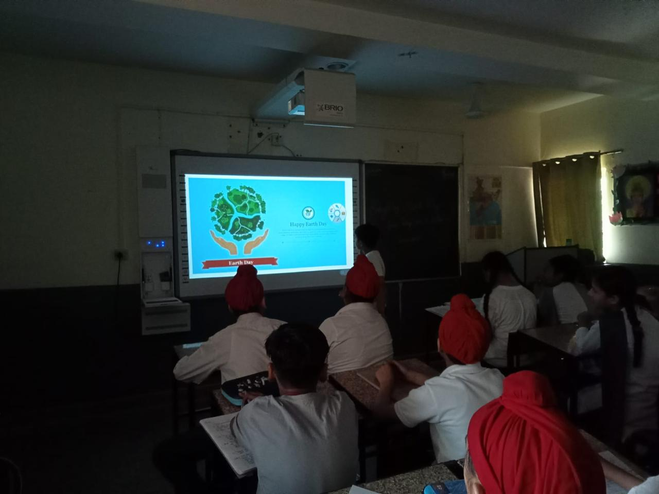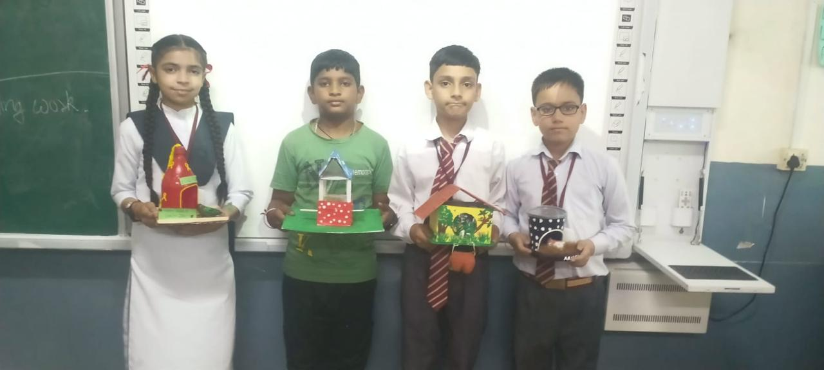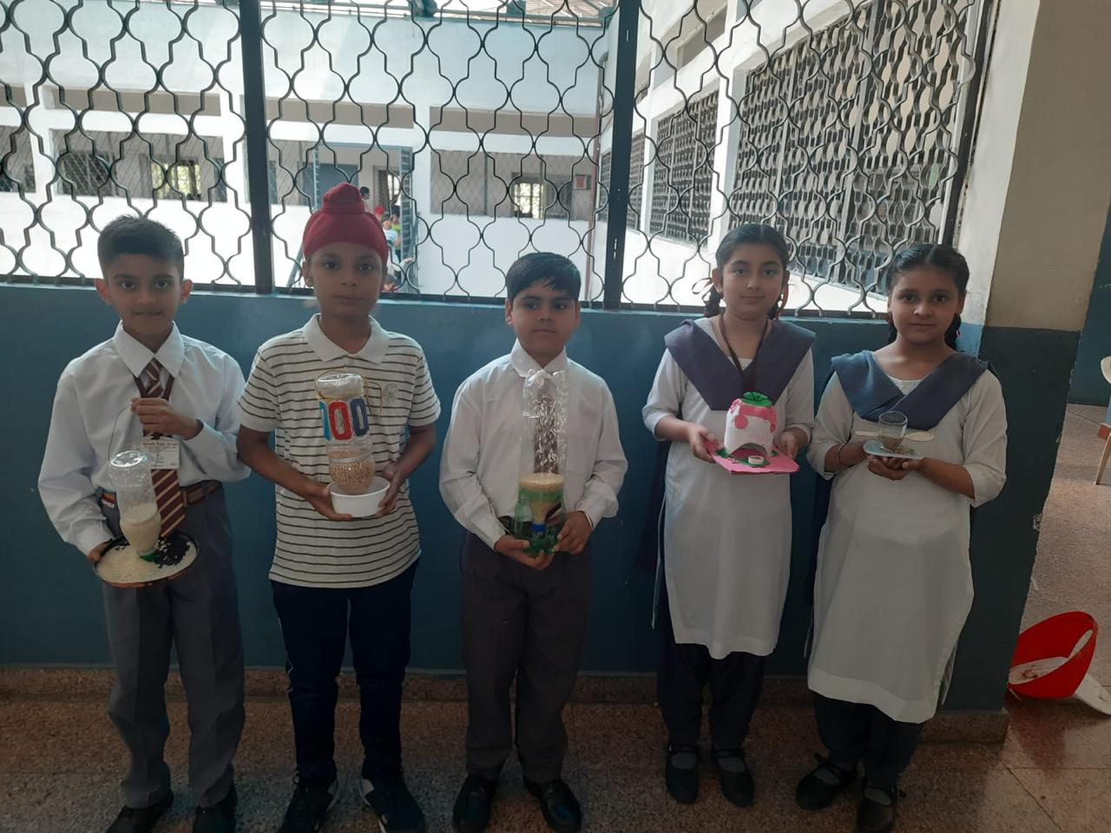The school is dedicated to fostering a culture of environmental consciousness and responsibility among its students, empowering them to become compassionate curators of the planet. Through our Earth Day celebrations, we aim to inspire action and raise awareness about the importance of preserving and protecting our natural world for generations to come.
