Shivalik Public School, Mohali celebrated its Annual Function and Prize Distribution Programme, ‘Expressions 2023’ amidst great zest, vibrancy and elation . The programme commenced with the lighting of the lamp of knowledge, by the Chief Guest, D.S. Bedi, School Director; and Guest of Honour, Mrs. Gurkiran Jeet Nalwa , Principal, Shivalik Public School, Chandigarh.
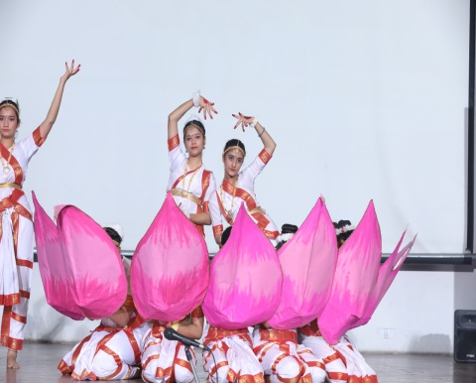
Principal of the School, Dr.( Mrs.)Anup Kiran Kaur presented the Annual Report of the session, 2023-24. The cultural programme, 'Expressions 2023' comprised theme-based western ,regional and folk dances and other performances depicting the pride, heritage and the contemporary scenario. The students also rendered euphonic songs. ‘Heal the world’ was well received. The students also performed on ‘Swachh Bharat Abhiyan’, Digital citizenship, success of G-20. They also celebrated the mission of ‘Chandrayan-3 and international medals of Indians in Asian Games and Olympics.
The theme- based dances were full of energy and enthusiasm showcased by the students of middle school. These performances enthralled the audience completely and there was a huge round of applause after every performance.
This was followed by the prize distribution ceremony where the chief guest gave away prizes to the meritorious students of the school.Guest of Honour, Mrs. Gurkiran Jeet Nalwa, in her concluding address appreciated the students for the magnificent programme presented and wished for their bright future .The programme culminated with a Grand Finale followed by National Anthem.

